****Service Request Management System****

The **Service Request Management System** is a lightweight web-based solution designed to streamline the creation, tracking, and management of service requests. The project integrates **automation, workflow orchestration, and API connectivity** to deliver a modern and flexible platform for both internal and external users.

The system is powered by **n8n** as the backend engine, which handles request workflows, data processing, and automation logic. The frontend is a simple yet user-friendly interface hosted on **GitHub Pages** for public access, and can also be deployed locally for internal use.

To securely expose the backend services to the internet, the project leverages **Ngrok**, enabling seamless broadcasting of APIs from the local environment without the need for complex server configurations. This setup allows the system to remain lightweight while still supporting real-time connectivity and integrations.

By combining **GitHub Pages, n8n, and Ngrok**, the Service Request Management System achieves:

✅ A **cost-efficient hosting model** (static frontend on GitHub Pages).

✅ **Automated backend workflows** using n8n (request handling, notifications, data routing).

✅ **Secure, internet-accessible APIs** through Ngrok tunneling.

✅ Flexible deployment (works both locally and online)

This approach makes the project highly adaptable for organizations that need a **scalable, open-source, and automation-friendly** way to manage service requests without heavy infrastructure costs.

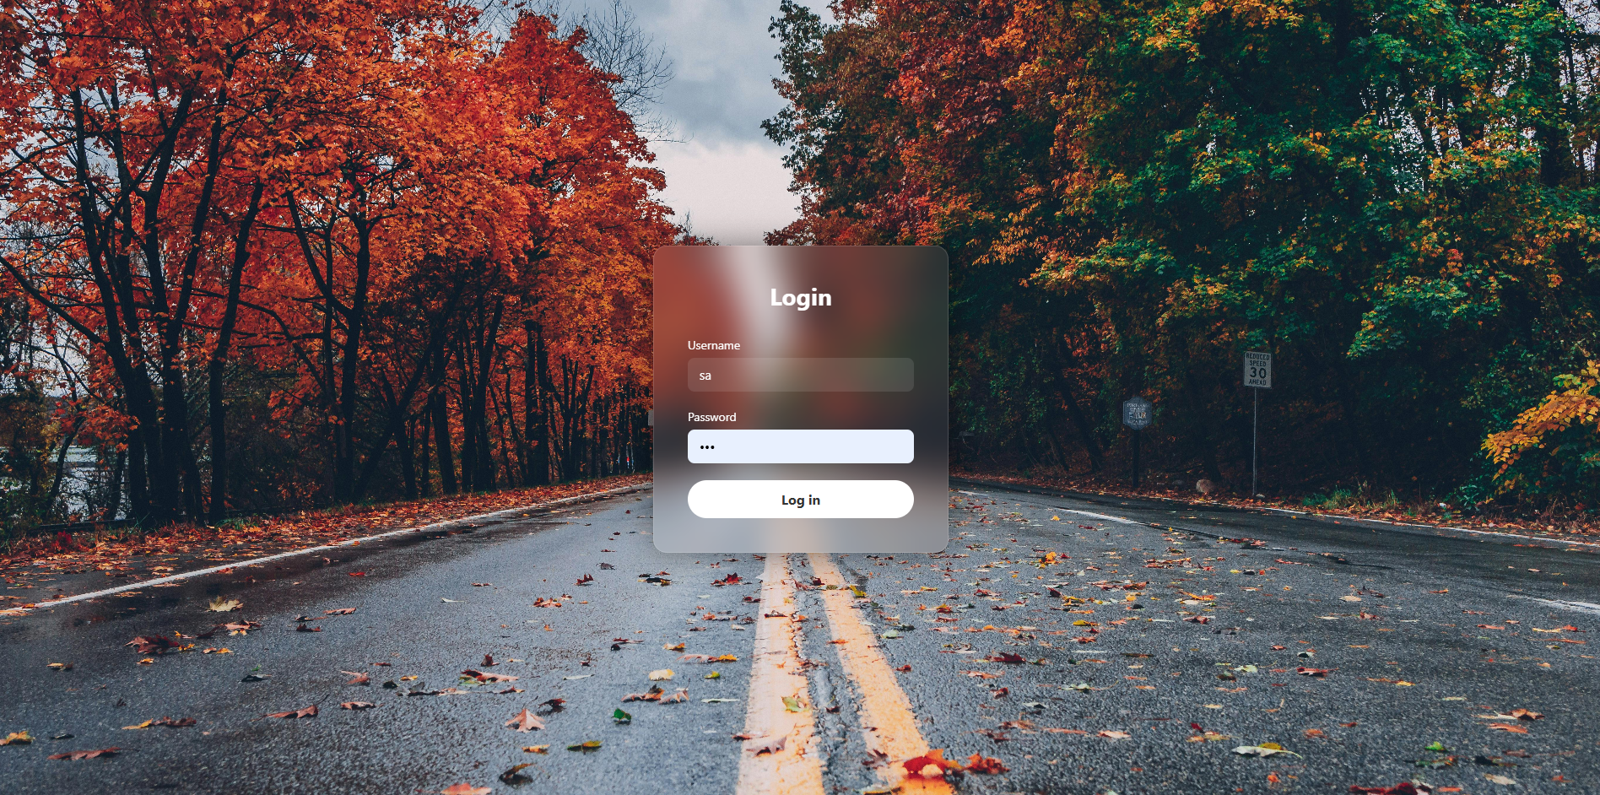

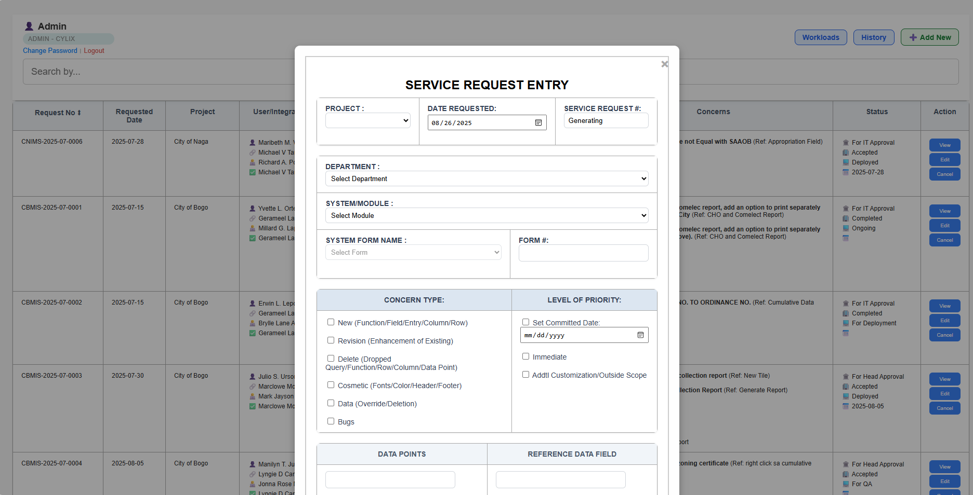

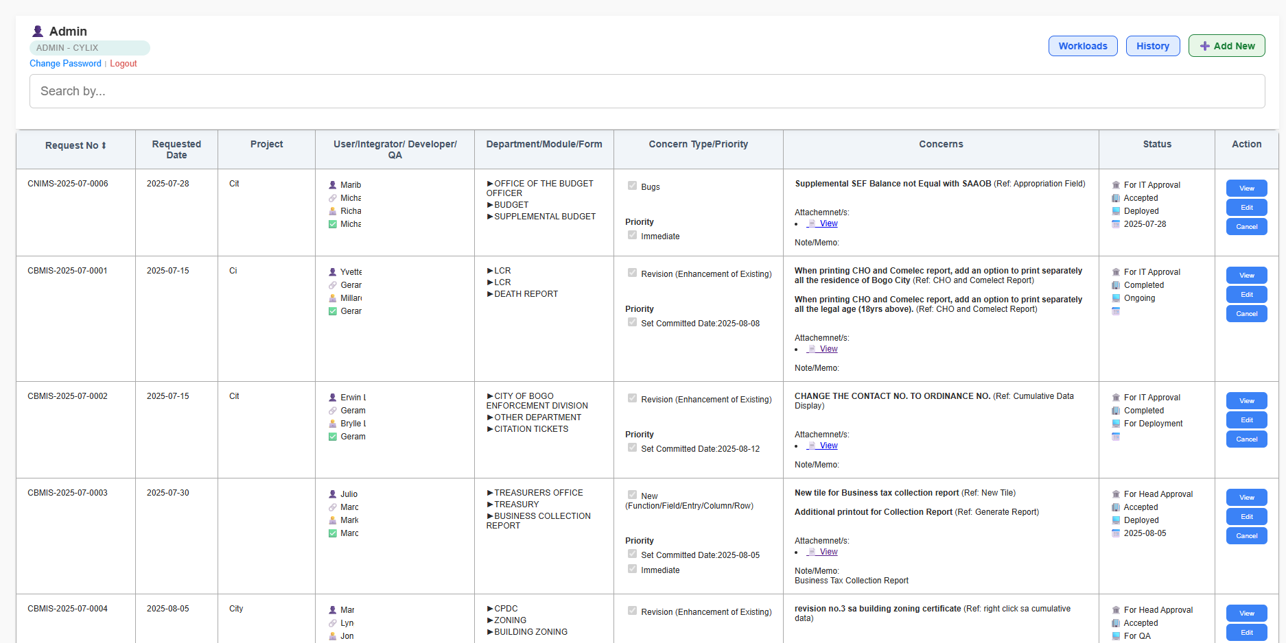

****Our Safe SPage Page for Automatic Posting****

This page is dedicated to sharing **daily thoughts, tips, and reminders about creating safe spaces for everyone**. Each post is powered by **ChatGPT**, bringing meaningful words of encouragement and guidance, while **Pexels** provides beautiful images to match every message.

Through **n8n automation**, posts are shared consistently each day — combining inspiring visuals and thoughtful reminders that promote **peace, kindness, and understanding** in our daily lives.

✨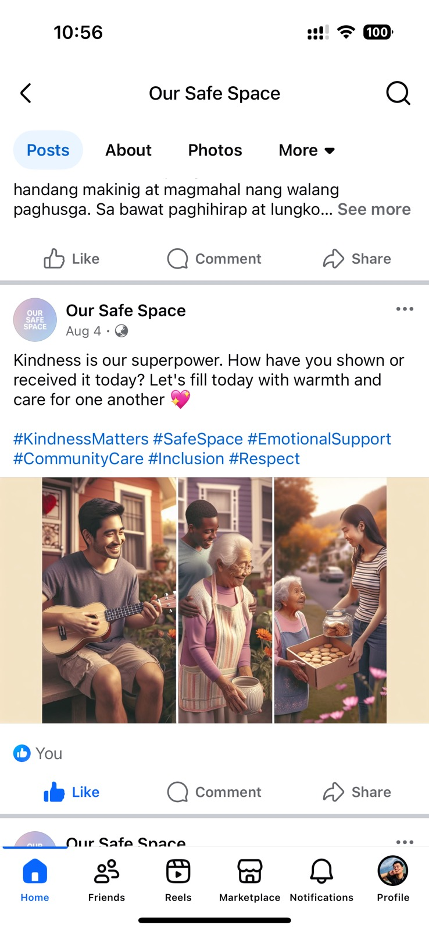



****Fetching Important Email From Gmail****

In today’s fast-paced environment, staying updated on important emails in real-time is essential. This project automates the process of **fetching important emails from Gmail** and instantly **sending notifications to WhatsApp**. By integrating Gmail’s API with a workflow automation tool (like n8n, Zapier, or custom scripts) and WhatsApp messaging services (Twilio WhatsApp API or Meta Cloud API), users can receive critical email updates directly on their mobile devices.

This system ensures that no urgent message is missed, providing a seamless bridge between email communication and instant messaging platforms. Whether it’s business alerts, customer inquiries, or system notifications, important Gmail messages will reach you immediately on WhatsApp for quick action.

